COVID Paper Results
Kyle Nickodem
January 06, 2026
Table of Contents
Preliminary Descriptives 1
Step 1 3
Step 2 6
Step 3 - Distal Outcomes 8

This is the sample of 460 students who responded to at least 1 coping strategy item.

Preliminary Descriptives
Supplemental Figure 1. Score Correlations
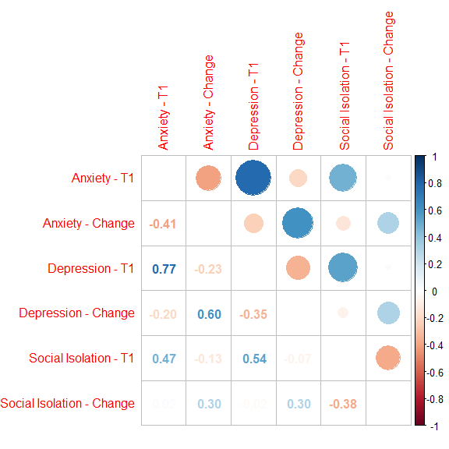
Supplemental Table 1. Descriptive Statistics for Included and Excluded Participants
Characteristic | Excluded, N = 664¹ | Included, N = 460¹ | p²
Anxiety - T1 | 5.2 (5.0)  [0.0-21.0] | 5.6 (4.8)  [0.0-21.0] | .20
Unknown | 92 | 8
Depression - T1 | 6.0 (5.0)  [0.0-24.0] | 6.4 (5.0)  [0.0-24.0] | .20
Unknown | 94 | 4
Social Isolation - T1 | 10.8 (3.5)  [4.0-20.0] | 11.5 (3.4)  [4.0-20.0] | < .01
Unknown | 124 | 19
Race/Ethnicity |  |  | .50
White alone | 416 (64%) | 276 (60%)
Black alone | 44 (6.8%) | 34 (7.4%)
Asian/PI alone | 93 (14%) | 81 (18%)
Hispanic | 53 (8.2%) | 44 (9.6%)
Other | 41 (6.3%) | 25 (5.4%)
Unknown | 17 | 0
Gender Identity |  |  | .01
Woman (incl. trans woman) | 389 (62%) | 319 (70%)
Man (incl. trans man) | 231 (37%) | 132 (29%)
Other | 9 (1.4%) | 3 (0.7%)
Unknown | 35 | 6
Sexual Orientation |  |  | .30
Straight | 541 (86%) | 375 (83%)
Lesbian/Gay | 22 (3.5%) | 25 (5.6%)
Bisexual | 58 (9.2%) | 39 (8.7%)
Other | 10 (1.6%) | 11 (2.4%)
Unknown | 33 | 10
First Generation | 98 (16%) | 87 (19%) | .20
Unknown | 57 | 2
Highest Parent Education |  |  | .50
High school/GED or less | 41 (6.7%) | 38 (8.3%)
Some college to Bachelor's | 239 (39%) | 185 (40%)
Beyond Bachelor's | 329 (54%) | 235 (51%)
Unknown | 55 | 2
¹Mean (SD)
[Minimum-Maximum]; n (%)
²Welch Two Sample t-test; Pearson's Chi-squared test

Categorical Predictors of Non-attrition
Parameter | OR | CI_low | CI_high | z | p
(Intercept) | .66 | .57 | .77 | -5.28 | .00
nonwhite | 1.12 | .88 | 1.43 | 0.90 | .37
(Intercept) | .81 | .70 | .94 | -2.83 | .00
male | .71 | .54 | .91 | -2.63 | .01
(Intercept) | .73 | .64 | .83 | -4.63 | .00
first_gen | 1.22 | .89 | 1.67 | 1.21 | .22
(Intercept) | .69 | .60 | .79 | -5.48 | .00
sgm | 1.24 | .89 | 1.71 | 1.27 | .20
(Intercept) | .71 | .60 | .84 | -3.94 | .00
hs_ba | 1.12 | .87 | 1.42 | 0.88 | .38
Continuous Predictors of Non-attrition
Variable | 0_n | 0_M | 0_SD | 1_n | 1_M | 1_SD | t | df | p | d
GAD | 572.00 | 5.16 | 5.01 | 452.00 | 5.60 | 4.78 | -1.41 | 986.67 | .16 | -.09
PHQ | 570.00 | 6.00 | 4.98 | 456.00 | 6.39 | 4.98 | -1.26 | 975.09 | .21 | -.08
PSI | 540.00 | 10.76 | 3.48 | 441.00 | 11.48 | 3.45 | -3.27 | 943.80 | .00 | -.21

Step 1
Table 1. Latent Profile Analysis Fit Statistics
K | LL | SABIC | CAIC | VLMRT | p | Entropy | Profile n
1.00 | -7734.84 | 15505.16 | 15555.25 | NA | NA | NA | 460
2.00 | -7478.68 | 15013.55 | 15092.85 | 500.65 | .00 | .86 | 345/115
3.00 | -7388.26 | 14853.42 | 14961.93 | 176.72 | .14 | .85 | 275/150/35
4.00 | -7326.43 | 14750.45 | 14888.18 | 120.85 | .03 | .83 | 146/229/54/31
5.00 | -7279.55 | 14677.39 | 14844.34 | 91.63 | .37 | .83 | 130/217/58/22/33
6.00 | -7252.06 | 14643.13 | 14839.29 | 53.72 | .34 | .83 | 19/220/65/79/51/26
7.00 | -7225.91 | 14611.52 | 14836.90 | 51.12 | .27 | .86 | 20/17/62/124/188/2/47
Note. K = number of profiles, LL = log-likelihood, BIC = Bayesian information criteria; SABIC, sample size adjusted BIC, CAIC = consistent Akaike information criterion, VLMRT = Vuong-Lo-Mendell-Rubin adjusted likelihood ratio test; Profile n is based on most likely profile membership.

Plot of information criteria values
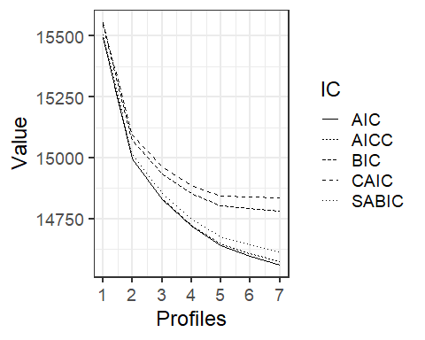
Indicator Means by Profile
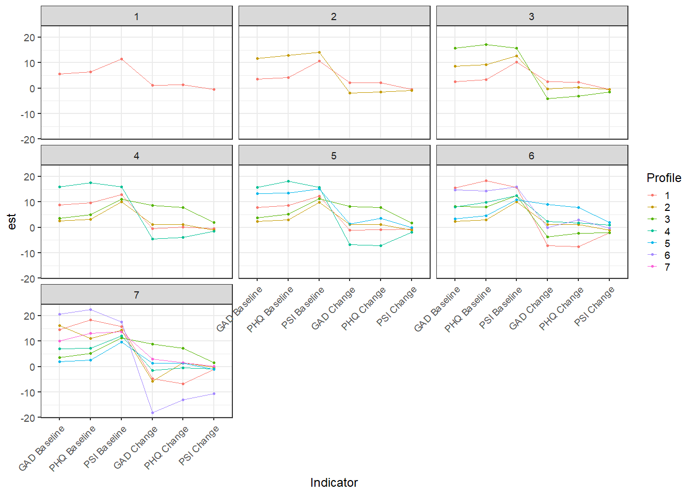
Indicator Means by Profile
Model | Indicator | 1 | 2 | 3 | 4 | 5 | 6 | 7
1.00 | GAD Baseline | 5.60 | NA | NA | NA | NA | NA | NA
1.00 | PHQ Baseline | 6.39 | NA | NA | NA | NA | NA | NA
1.00 | PSI Baseline | 11.48 | NA | NA | NA | NA | NA | NA
1.00 | GAD Change | 1.14 | NA | NA | NA | NA | NA | NA
1.00 | PHQ Change | 1.26 | NA | NA | NA | NA | NA | NA
1.00 | PSI Change | -.56 | NA | NA | NA | NA | NA | NA
2.00 | GAD Baseline | 3.56 | 11.62 | NA | NA | NA | NA | NA
2.00 | PHQ Baseline | 4.24 | 12.87 | NA | NA | NA | NA | NA
2.00 | PSI Baseline | 10.59 | 14.19 | NA | NA | NA | NA | NA
2.00 | GAD Change | 2.14 | -1.86 | NA | NA | NA | NA | NA
2.00 | PHQ Change | 2.14 | -1.44 | NA | NA | NA | NA | NA
2.00 | PSI Change | -.42 | -.98 | NA | NA | NA | NA | NA
3.00 | GAD Baseline | 2.65 | 8.56 | 15.68 | NA | NA | NA | NA
3.00 | PHQ Baseline | 3.41 | 9.34 | 17.12 | NA | NA | NA | NA
3.00 | PSI Baseline | 10.22 | 12.77 | 15.83 | NA | NA | NA | NA
3.00 | GAD Change | 2.56 | -.23 | -4.06 | NA | NA | NA | NA
3.00 | PHQ Change | 2.32 | 0.32 | -3.10 | NA | NA | NA | NA
3.00 | PSI Change | -.51 | -.44 | -1.39 | NA | NA | NA | NA
4.00 | GAD Baseline | 8.85 | 2.58 | 3.64 | 15.86 | NA | NA | NA
4.00 | PHQ Baseline | 9.63 | 3.16 | 5.00 | 17.53 | NA | NA | NA
4.00 | PSI Baseline | 12.83 | 10.11 | 11.11 | 15.90 | NA | NA | NA
4.00 | GAD Change | -.48 | 1.08 | 8.70 | -4.62 | NA | NA | NA
4.00 | PHQ Change | 0.08 | 1.10 | 7.75 | -3.92 | NA | NA | NA
4.00 | PSI Change | -.44 | -1.09 | 1.89 | -1.45 | NA | NA | NA
5.00 | GAD Baseline | 7.84 | 2.35 | 3.79 | 15.67 | 13.22 | NA | NA
5.00 | PHQ Baseline | 8.60 | 2.92 | 5.18 | 18.26 | 13.54 | NA | NA
5.00 | PSI Baseline | 12.36 | 9.94 | 11.30 | 15.68 | 15.05 | NA | NA
5.00 | GAD Change | -1.16 | 1.20 | 8.31 | -6.85 | 1.38 | NA | NA
5.00 | PHQ Change | -.96 | 1.17 | 7.76 | -7.08 | 3.50 | NA | NA
5.00 | PSI Change | -.74 | -1.06 | 1.72 | -1.87 | -.07 | NA | NA
6.00 | GAD Baseline | 15.62 | 2.44 | 8.22 | 7.94 | 3.31 | 14.75 | NA
6.00 | PHQ Baseline | 18.44 | 3.01 | 8.05 | 9.88 | 4.62 | 14.27 | NA
6.00 | PSI Baseline | 15.65 | 10.02 | 12.50 | 12.52 | 10.91 | 15.86 | NA
6.00 | GAD Change | -7.24 | 1.09 | -3.65 | 2.45 | 9.11 | -0.04 | NA
6.00 | PHQ Change | -7.64 | 1.15 | -2.37 | 1.80 | 7.77 | 2.99 | NA
6.00 | PSI Change | -2.15 | -1.07 | -2.04 | 0.89 | 1.91 | -0.33 | NA
7.00 | GAD Baseline | 14.51 | 16.05 | 3.68 | 7.01 | 2.01 | 20.50 | 10.00
7.00 | PHQ Baseline | 18.34 | 11.05 | 5.23 | 7.26 | 2.59 | 22.50 | 13.10
7.00 | PSI Baseline | 15.75 | 14.35 | 11.36 | 12.18 | 9.69 | 17.50 | 13.71
7.00 | GAD Change | -4.67 | -5.68 | 8.75 | -1.48 | 1.28 | -18.00 | 2.99
7.00 | PHQ Change | -6.66 | 1.57 | 7.23 | -.56 | 1.34 | -13.00 | 1.52
7.00 | PSI Change | -1.04 | -.28 | 1.51 | -.98 | -1.01 | -10.51 | 0.23

Step 2
Table 2. Mental health indicators and demographic variables by profile
Characteristic | Overall, N = 460¹ | 1, N = 19¹ | 2, N = 220¹ | 3, N = 65¹ | 4, N = 79¹ | 5, N = 51¹ | 6, N = 26¹
Anxiety - T1 | 5.60 (4.78) | 15.53 (4.18) | xx | 8.35 (2.75) | 8.05 (2.35) | xx | 15.12 (2.66)
Depression - T1 | 6.39 (4.98) | 18.53 (3.24) | xx | 8.17 (2.63) | 10.05 (2.96) | xx | 14.27 (3.41)
Social Isolation - T1 | 11.48 (3.45) | 15.63 (3.80) | 10.05 (2.88) | 12.59 (3.25) | 12.47 (2.76) | 10.86 (2.96) | 16.13 (2.40)
Anxiety - Change | 1.13 (4.95) | xx | xx | xx | xx | 9.52 (3.72) | xx
Depression - Change | 1.26 (4.75) | xx | xx | xx | xx | 8.06 (4.20) | xx
Social Isolation - Change | -0.55 (3.23) | xx | xx | xx | xx | xx | xx
Race/Ethnicity
White alone | 276 (60%) | 11 (58%) | 127 (58%) | 45 (69%) | 48 (61%) | 32 (63%) | 13 (50%)
Black alone | 34 (7.4%) | xx | 14 (6.4%) | xx | xx | xx | 9 (35%)
Asian/PI alone | 81 (18%) | xx | 44 (20%) | 8 (12%) | 14 (18%) | 9 (18%) | xx
Hispanic | 44 (9.6%) | xx | 25 (11%) | 7 (11%) | 8 (10%) | xx | xx
Other | 25 (5.4%) | xx | 10 (4.5%) | xx | 6 (7.6%) | xx | xx
Gender Identity
Woman (incl. trans woman) | 319 (70%) | 13 (72%) | 145 (67%) | 44 (68%) | 64 (82%) | 33 (65%) | 20 (77%)
Man (incl. trans man) | 132 (29%) | xx | 71 (33%) | 21 (32%) | 13 (17%) | 18 (35%) | xx
Other | 3 (0.7%) | xx | xx | xx | xx | xx | xx
Sexual Orientation
Straight | 375 (83%) | 12 (71%) | 200 (92%) | 55 (86%) | 52 (69%) | 38 (75%) | 18 (72%)
Lesbian/Gay | 25 (5.6%) | xx | 7 (3.2%) | xx | 6 (8.0%) | xx | xx
Bisexual | 39 (8.7%) | xx | 11 (5.0%) | xx | 12 (16%) | 8 (16%) | xx
Other | 11 (2.4%) | xx | xx | xx | xx | xx | xx
First Generation Student | 87 (19%) | xx | 43 (20%) | 16 (25%) | 13 (17%) | 6 (12%) | xx
collapse_hpe
High school/GED or less | 38 (8.3%) | xx | 17 (7.7%) | 9 (14%) | xx | xx | xx
Some college to Bachelor's | 185 (40%) | 8 (42%) | 95 (43%) | 25 (38%) | 29 (37%) | 17 (33%) | 11 (44%)
Beyond Bachelor's | 235 (51%) | 9 (47%) | 108 (49%) | 31 (48%) | 44 (56%) | 31 (61%) | 12 (48%)
¹Mean (SD); n (%)

Model Estimated Addendum
Indicator | 1 | 2 | 3 | 4 | 5 | 6
GAD Baseline | 15.62 | 2.44 | 8.22 | 7.95 | 3.31 | 14.75
PHQ Baseline | 18.44 | 3.01 | 8.05 | 9.88 | 4.62 | 14.27
PSI Baseline | 15.65 | 10.02 | 12.50 | 12.52 | 10.91 | 15.86
GAD Change | -7.24 | 1.09 | -3.65 | 2.45 | 9.11 | -0.04
PHQ Change | -7.64 | 1.15 | -2.37 | 1.80 | 7.77 | 2.99
PSI Change | -2.15 | -1.07 | -2.04 | 0.89 | 1.91 | -0.33
Note. ªMean and SD (in parenthesis) in Overall column are observed sample statistics whereas means in profile columns are model estimated. At Time 1, the full range of values for anxiety (0 – 21), depression (0 – 24), and social isolation (0 – 20) were observed. Bold = score indicates severe anxiety (> 10) or depression (≥ 15); italics = score indicates moderate anxiety (> 5 and ≤10) or mild to moderate depression (≥5 and <15). There are no clinical ranges for social isolation. = Cell counts < 5 are suppressed to avoid presentation of unstable results and protect confidentiality. NH = non-Hispanic.
X2 tests - Not used in manuscript
group | x2 | df | p
race | 22.11 | 15.00 | .10
gender identity | 9.55 | 5.00 | .09
sexual orientation | 34.73 | 5.00 | .00
first generation | 4.19 | 5.00 | .52
highest parental education | 6.49 | 10.00 | .77

Step 3 - Distal Outcomes
Figure 1. Probability of Using Coping Strategy by Profile
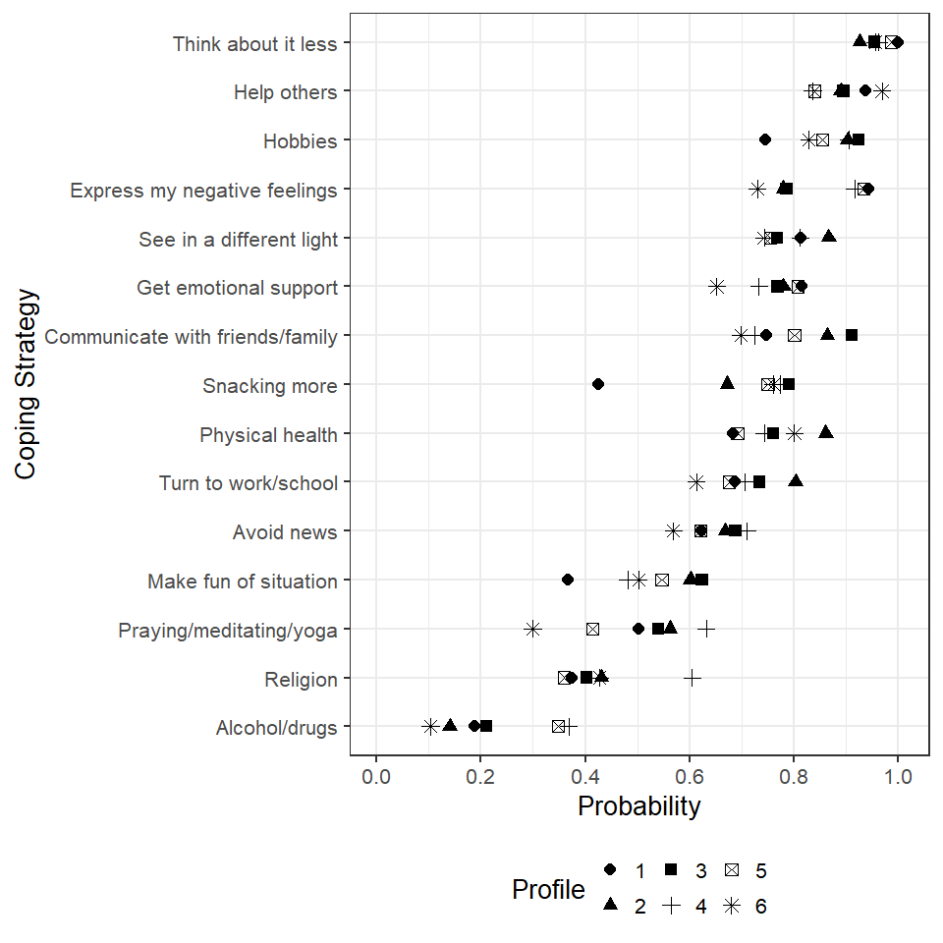

Supplemental Table 2. Probability of Using Coping Strategy by Profile
Strategy | 1 | 2 | 3 | 4 | 5 | 6
Think about it less | 1.00 | .93 | .95 | .96 | .99 | .96
Help others | .94 | .89 | .90 | .84 | .84 | .97
Hobbies | .74 | .90 | .92 | .90 | .86 | .83
Express my negative feelings | .94 | .78 | .79 | .92 | .93 | .73
See in a different light | .81 | .87 | .77 | .81 | .76 | .74
Get emotional support | .82 | .78 | .77 | .73 | .81 | .65
Communicate with friends/family | .75 | .86 | .91 | .72 | .80 | .70
Snacking more | .42 | .67 | .79 | .77 | .75 | .76
Physical health | .68 | .86 | .76 | .74 | .69 | .80
Turn to work/school | .69 | .80 | .73 | .71 | .68 | .61
Avoid news | .62 | .67 | .69 | .71 | .62 | .57
Make fun of situation | .37 | .60 | .62 | .48 | .55 | .50
Praying/meditating/yoga | .50 | .56 | .54 | .63 | .41 | .30
Religion | .37 | .43 | .40 | .60 | .36 | .43
Alcohol/drugs | .19 | .14 | .21 | .37 | .35 | .10
Latent Profile Odds Ratios
There were a total of 225 comparisons (i.e., one for each profile pair on each of the 15 coping strategies). The P.adj column is the Benjamini-Hochberg adjustment to the p-value to manage the false discovery rate. Only comparisons with p < .10 (i.e., the P column, not the P.adj column) are presented here. An OR < 1 implies the first profile in the Comp column is less likely than the second profile to use the coping strategy.
Comp | Strategy | OR | SE | z | p | p.adj
1 to 2 | Hobbies | 0.31 | .20 | -3.38 | .00 | .01
1 to 2 | Communicate with friends/family | 0.47 | .30 | -1.81 | .07 | .50
1 to 2 | Make fun of situation | 0.38 | .22 | -2.86 | .00 | .05
1 to 2 | Physical health | 0.35 | .21 | -3.10 | .00 | .03
1 to 2 | Snacking more | 0.36 | .20 | -3.23 | .00 | .02
1 to 3 | Hobbies | 0.24 | .20 | -3.82 | .00 | .00
1 to 3 | Communicate with friends/family | 0.29 | .24 | -2.94 | .00 | .04
1 to 3 | Make fun of situation | 0.35 | .22 | -2.96 | .00 | .04
1 to 3 | Snacking more | 0.20 | .13 | -6.34 | .00 | .00
1 to 4 | Hobbies | 0.31 | .24 | -2.82 | .00 | .05
1 to 4 | Alcohol/drugs | 0.40 | .29 | -2.07 | .04 | .32
1 to 4 | Snacking more | 0.22 | .14 | -5.65 | .00 | .00
1 to 4 | Religion | 0.39 | .24 | -2.51 | .01 | .10
1 to 5 | Alcohol/drugs | 0.43 | .32 | -1.76 | .08 | .54
1 to 5 | Think about it less | 29.40 | .00 | Inf | .00 | .00
1 to 5 | Make fun of situation | 0.48 | .30 | -1.72 | .09 | .57
1 to 5 | Snacking more | 0.25 | .16 | -4.77 | .00 | .00
1 to 6 | Snacking more | 0.23 | .18 | -4.17 | .00 | .00
2 to 3 | Snacking more | 0.54 | .23 | -2.00 | .04 | .34
2 to 4 | Alcohol/drugs | 0.28 | .11 | -6.37 | .00 | .00
2 to 4 | Religion | 0.49 | .18 | -2.78 | .00 | .06
2 to 4 | Express my negative feelings | 0.32 | .22 | -3.12 | .00 | .03
2 to 5 | Alcohol/drugs | 0.31 | .13 | -5.38 | .00 | .00
2 to 5 | Think about it less | 0.18 | .29 | -2.78 | .00 | .06
2 to 5 | Express my negative feelings | 0.25 | .18 | -4.08 | .00 | .00
2 to 6 | Help others | 0.25 | .41 | -1.83 | .07 | .50
3 to 4 | Alcohol/drugs | 0.46 | .24 | -2.22 | .03 | .22
3 to 4 | Religion | 0.44 | .22 | -2.59 | .01 | .09
3 to 4 | Express my negative feelings | 0.33 | .26 | -2.52 | .01 | .10
3 to 5 | Alcohol/drugs | 0.50 | .24 | -2.04 | .04 | .32
3 to 5 | Express my negative feelings | 0.26 | .20 | -3.69 | .00 | .00
4 to 6 | Help others | 0.16 | .27 | -3.11 | .00 | .03
5 to 6 | Help others | 0.16 | .27 | -3.08 | .00 | .03
Table 3. Odds ratio (standard error) of profile membership for demographic variables
Covariate | 1 | 3 | 4 | 5 | 6
NONWHITE | 0.75 (0.46) | 0.53 (0.20) | 0.84 (0.34) | 0.86 (0.34) | 1.17 (0.58)
MALE | 0.50 (0.35) | 1.04 (0.39) | 0.24 (0.14) | 0.94 (0.39) | 0.29 (0.22)
SGM | 7.36 (5.32) | 1.73 (1.12) | 10.07 (5.05) | 6.69 (3.48) | 9.36 (5.85)
FG | 1.05 (0.90) | 1.70 (0.84) | 0.58 (0.36) | 0.53 (0.36) | 0.48 (0.37)
HS_BA | 1.28 (0.80) | 0.94 (0.39) | 0.93 (0.41) | 0.75 (0.32) | 1.60 (0.87)
Note. Profile 2 (low-stable, n = 220) was the reference group.

